SQL QUERIES
COFFEE SALES SHOP PROJECT

CONVERT DATE (transaction_date) COLUMN TO PROPER DATE FORMAT
UPDATE coffee_shop_sales
SET transaction_date = STR_TO_DATE(transaction_date, '%d-%m-%Y');

ALTER DATE (transaction_date) COLUMN TO DATE DATA TYPE
ALTER TABLE coffee_shop_sales
MODIFY COLUMN transaction_date DATE;

CONVERT TIME (transaction_time) COLUMN TO PROPER DATE FORMAT
update coffee_data
set transaction_time = str_to_date(transaction_time, '%H-%i-%s');

ALTER TIME (transaction_time) COLUMN TO DATE DATA TYPE
Alter table coffee_data
modify column transaction_time TIME;

CHANGE COLUMN NAME `ï»¿transaction_id` to transaction_id
alter table coffee_data
change column ï»¿transaction_id transaction_id int;

DATA TYPES OF DIFFERENT COLUMNS
Describe coffee_data;
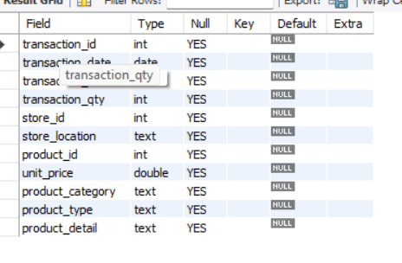

TOTAL SALES
select concat((Round(sum(unit_price * transaction_qty)))/1000,'K') as totals_sales
from coffee_data
where month(transaction_date)=5; -- may month
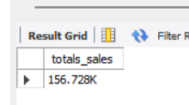

TOTAL SALES KPI - MOM DIFFERENCE AND MOM GROWTH
select month(transaction_date) as month,
sum(unit_price * transaction_qty) as total_sales,
sum(unit_price * transaction_qty) - lag(sum(unit_price * transaction_qty), 1)
over(order by month(transaction_date))/ lag(sum(unit_price * transaction_qty), 1)
over (order by month(transaction_date))* 100 as mom_increase_percentage
from coffee_data
where month(transaction_date) in (4,5) -- curtmonth - may=5
-- perviosmonth - April =4
group by month(transaction_date)
order by month(transaction_date);
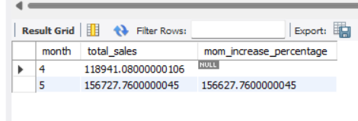

TOTAL ORDERS
select count(transaction_id) as total_orders
from coffee_data
where month(transaction_date) = 2;
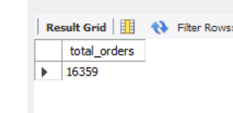

TOTAL ORDERS KPI - MOM DIFFERENCE AND MOM GROWTH
select month(transaction_date) as month,
count(transaction_id) as total_orders,
(count(transaction_id) - lag(count(transaction_id),1)
over( order by month(transaction_date)))/ lag(count(transaction_id),1)
over(order by month(transaction_date))* 100 as diff_count_of_month
from coffee_data
where month(transaction_date) in (4,5)
group by month(transaction_date)
order by month(transaction_date);
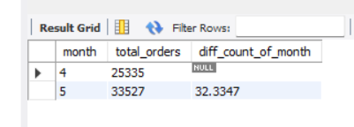

TOTAL QUANTITY SOLD
select sum(transaction_qty) as total_qty
from coffee_data
where month(transaction_date)=6;
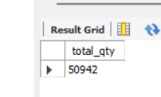

TOTAL QUANTITY SOLD KPI - MOM DIFFERENCE AND MOM GROWTH
select month(transaction_date) as month,
sum(transaction_qty) as total_qty,
(sum(transaction_qty) - lag(sum(transaction_qty),1)
over(order by month(transaction_date)))/ lag(sum(transaction_qty),1)
over(order by month(transaction_date)) * 100 as mom_diff_percent
from coffee_data
where month(transaction_date) in (4,5)
group by month(transaction_date)
order by month(transaction_date);
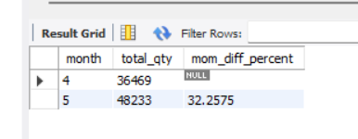

CALENDAR TABLE – DAILY SALES, QUANTITY and TOTAL ORDERS
select sum(unit_price * transaction_qty) as total_sales,
sum(transaction_qty) as total_qty_sold,
count(transaction_id) as total_orders
from coffee_data
where transaction_date = '2023-05-18';
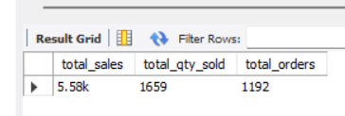

SALES TREND OVER PERIOD
select
concat(round(avg(total_sales)/1000,1),'k') as avg_sales
from
(select sum(unit_price * transaction_qty) as total_sales
from coffee_data
where month(transaction_date)=5
group by transaction_date
) as internal_query;
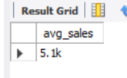

DAILY SALES FOR MONTH SELECTED
select day(transaction_date)as day_of_month,
round(sum(unit_price * transaction_qty),1) as total_sales
from coffee_data
where month(transaction_date)=5
group by day(transaction_date)
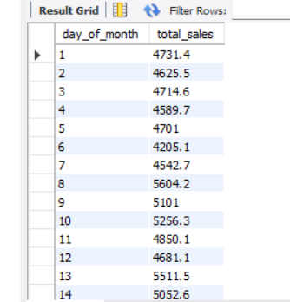
order by day(transaction_date)
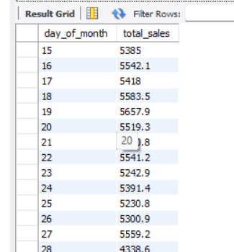

COMPARING DAILY SALES WITH AVERAGE SALES – IF GREATER THAN “ABOVE AVERAGE” and LESSER THAN “BELOW AVERAGE”
select day_of_month,
case
when total_sales > avg_sales then 'above average'
when total_sales < avg_sales then 'below average'
else 'equal_to_average'
end as sales_status , total_sales
from ( select day(transaction_date) as day_of_month,
sum(unit_price * transaction_qty) as total_sales,
avg(sum(unit_price * transaction_qty))over() as avg_sales
from coffee_data
where month(transaction_date)= 5
group by day(transaction_date)
) as sales_data order by day_of_month

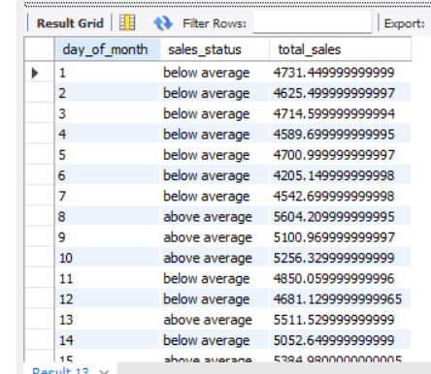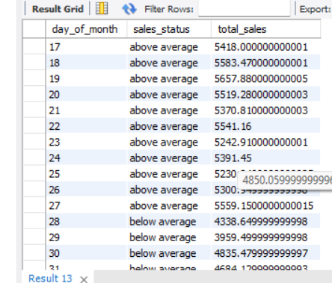
SALES BY WEEKDAY / WEEKEND:
CREATE PROCEDURE `sales_weekday_weekend`(in input_month int)
BEGIN
select
case when dayofweek(transaction_date) in (1,7) then 'weekend'
else 'weekdays'
end as day_type,
concat(round(sum(unit_price * transaction_id)/1000 ,1),'k') as total_sales
from coffee_data
where
MONTH(transaction_date)=input_month
group by case when dayofweek(transaction_date) in (1,7) then 'weekend'
else 'weekdays'
end;
END
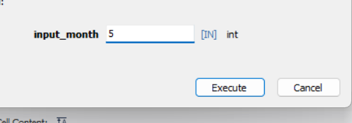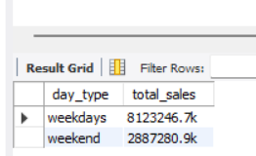

SALES BY STORE LOCATION
select store_location , concat(round(sum(unit_price * transaction_qty)/1000,2),'k') as total_sales
from coffee_data
where month(transaction_date)=5
group by store_location
order by total_sales desc;
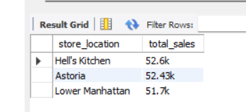
SALES BY PRODUCT CATEGORY
select product_category ,sum(unit_price * transaction_qty) as total_sales
from coffee_data
where month(transaction_date)=5
group by product_category;
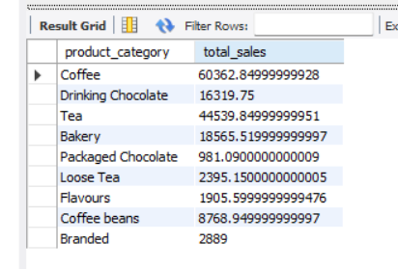
SALES BY PRODUCTS (TOP 10)
select product_type , sum(unit_price * transaction_qty) as total_sales
from coffee_data
where month(transaction_date)=5 -- may month
group by product_type
order by total_sales desc
limit 10;

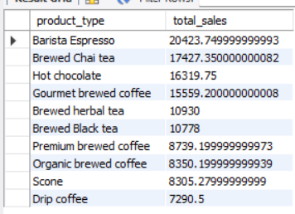

SALES BY DAY | HOUR
select sum(unit_price * transaction_qty) as total_sales,
sum(transaction_qty) as total_qty_sold,
count(transaction_qty) as total_orders
from coffee_data
where month(transaction_date)=4 -- april month
and dayofweek(transaction_date)= 3 -- day in month
and hour(transaction_time)=8; -- hour
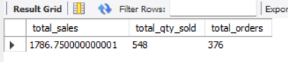

TO GET SALES FROM MONDAY TO SUNDAY FOR MONTH OF MAY
select
case
when dayofweek(transaction_date)=2 then 'MONDAY'
when dayofweek(transaction_date)=3 then 'TUESDAY'
when dayofweek(transaction_date)=4 then 'WEDNESDAY'
when dayofweek(transaction_date)=5 then 'THURSDAY'
when dayofweek(transaction_date)=6 then 'FRIDAY'
when dayofweek(transaction_date)=7 then 'SATURDAY'
ELSE 'SUNDAY'
END AS DAY_OF_WEEK,
ROUND(sum(unit_price * transaction_qty)) as total_sales
from coffee_data
where month(transaction_date) = 5
group by case
when dayofweek(transaction_date)=2 then 'MONDAY'
when dayofweek(transaction_date)=3 then 'TUESDAY'
when dayofweek(transaction_date)=4 then 'WEDNESDAY'
when dayofweek(transaction_date)=5 then 'THURSDAY'
when dayofweek(transaction_date)=6 then 'FRIDAY'
when dayofweek(transaction_date)=7 then 'SATURDAY'
ELSE 'SUNDAY'
end;
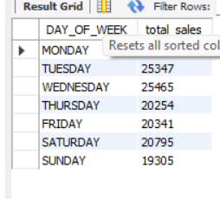
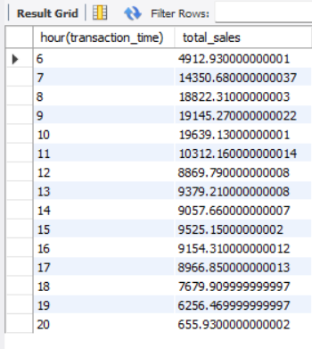
TO GET SALES FOR ALL HOURS FOR MONTH OF MAY
select hour(transaction_time),
sum(unit_price * transaction_qty) as total_sales
from coffee_data
where month(transaction_date)=5
group by hour(transaction_time)
order by hour(transaction_time) asc;

